# STEPS FOR TASK 1

1. CONNECT TO THE DATABASE
2. CREATE DATABASE NAMED DWH ASSIGNMENT
3. CREATE TABLE dbo.Customers
4. Dbo.Customers contain id,firstname,lastname,address,phone_number
5. Configure connection managers for csv file and sql server
6. Define data flow for this task to integrate csv with sql server

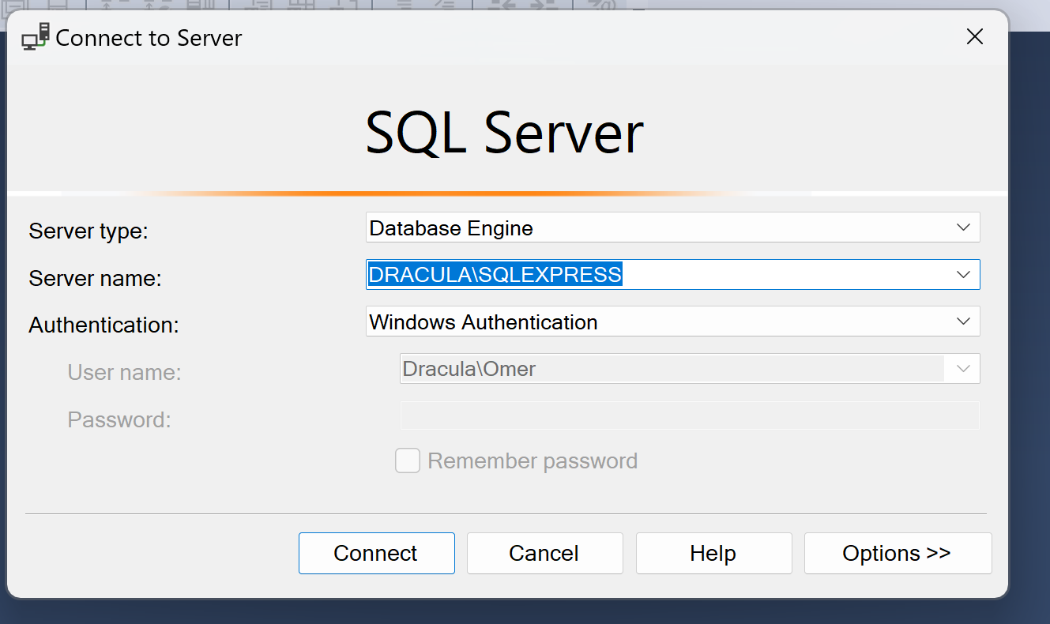

## DATABASE TABLE COLUMNS FOR TASK 1

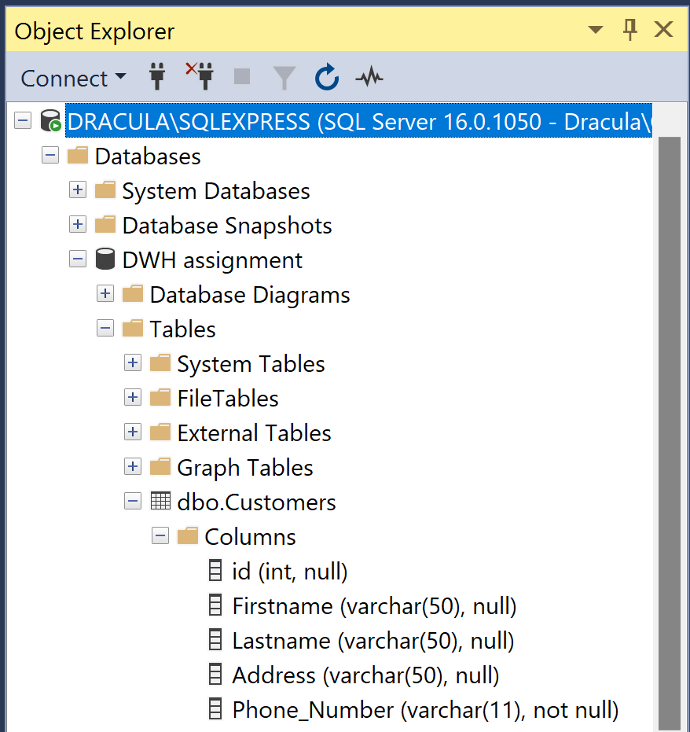

## SQL SCRIPT FOR TASK 1

use [DWH assignment ];

create table dbo.Customers(

id int,

Firstname varchar(50),

Lastname varchar(50),

Address varchar(50),

Phone_Number varchar(11)

);

select * from dbo.Customers;

### CSV FILE FOR TASK 1

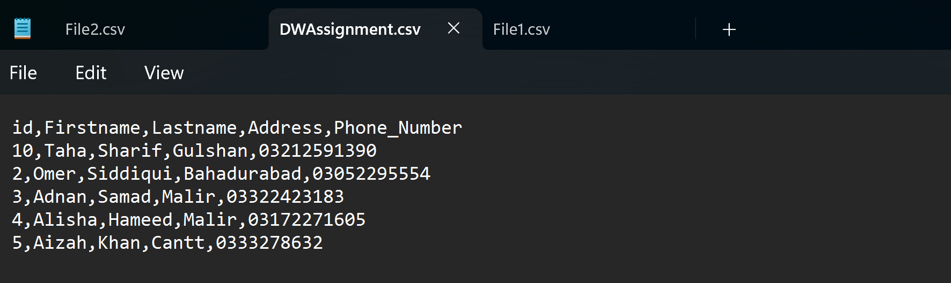

### INTEGRATION TASK 1

